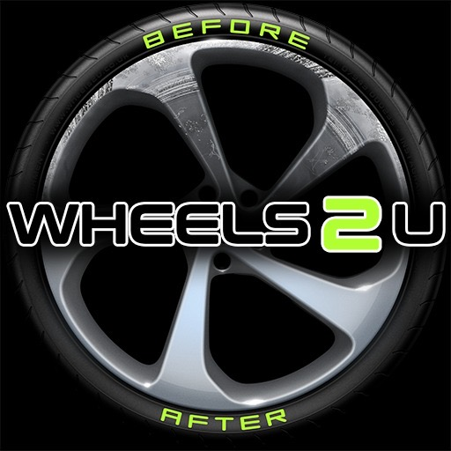 |  | Mobile alloy wheel technician  -roles available:  Part-time Support Technician: from £400/week + bonuses  Full-time Lead Technician: from £25k-£30k OTE  Owner: ~£60k-£80k of customer leads/year.  (As an owner you may cover multiple areas & operate as a one or two person team. You will either already have your own van & tools or rent one from us. We will generate the customer enquiries & deal with all the financial/admin paperwork.)  Location: Mobile customer visits around the West Midlands.  (~30 mile radius of Birmingham.)  Hours: Flexible depending on how much you want to earn, appointments throughout the week & how you prefer to schedule evening & weekend slots.
The Company  Wheels2U is a local, family run business operating our mobile alloy wheel repair, refurbishment & respray service across the West Midlands; including Birmingham, Sandwell, West Bromwich, Halesowen, Dudley & the Black Country.  Unlike most other alloy repair companies our customised Mercedes workshops go to the customer so they don't have to lose their car or sit around a garage.  What we do  More details about the services we provide and the type of work we perform is detailed on our website:  https://wheels2u.co.uk/  Contact  Carl Adkins  Telephone: 07943 000235  Email: info@wheels2u.co.uk  https://wheels2u.co.uk/ |  | Experience  Essential:  Previous experience repairing, refurbing and powder coating/respraying alloy wheels in a body shop, garage etc. is essential.  Obviously, as a mobile business then Lead Technicians also require a full UK (or equivalent) driving licence. Support Technicians (as part of a two person team) should hold at least a provisional driving licence.  Excellent communication & customer service skills are essential because Wheels2U is a family local business not a high volume, sweat shop: we & our customers expect quality work & professional service.  Nice to have:  It would be great if you’ve also had experience repairing Diamond Cut wheels, performing SMART repairs, car detailing & worked mobile before,  Are we a good match?  So; you have the experience & desire but do we share the same values? These are the core values we strive for:  Customer Satisfaction  - Doing your best to make sure that your customer is happy to use us again & would recommend us to friends and family.  Quality Work  - Being proud of the work you have done & always trying to perfect your techniques so your customers will happily recommend Wheels2U to their friends & family.  Personal & Financial Growth  - Always learning, meeting new people and wanting to build a career, not just a job, that makes you happy & financially rewarded.  If you also share these same values then we need to talk!  I

